Configure the local node | 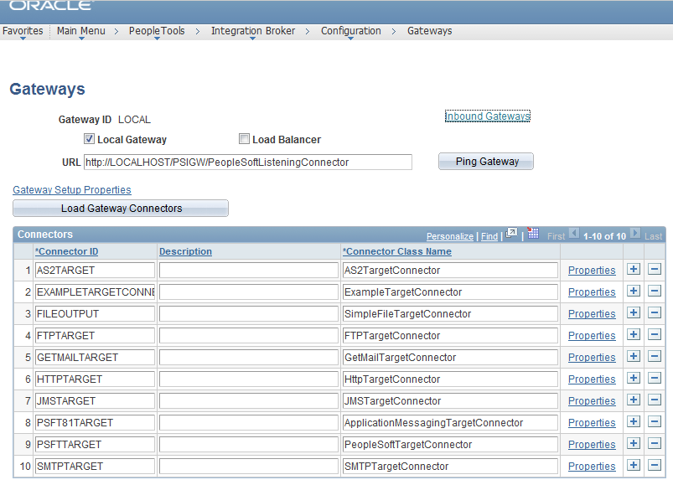
Configure the local node | 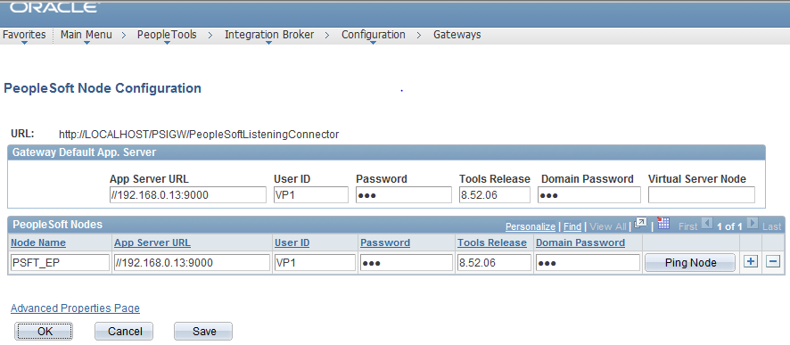
Ping Node | 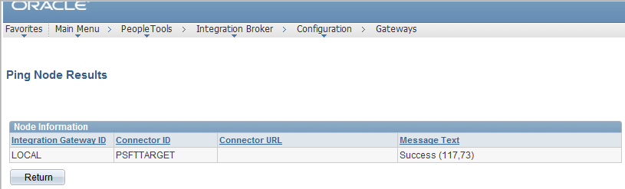
Had to change the local node PSFT_EP from Authentication None to Password and provide password. | 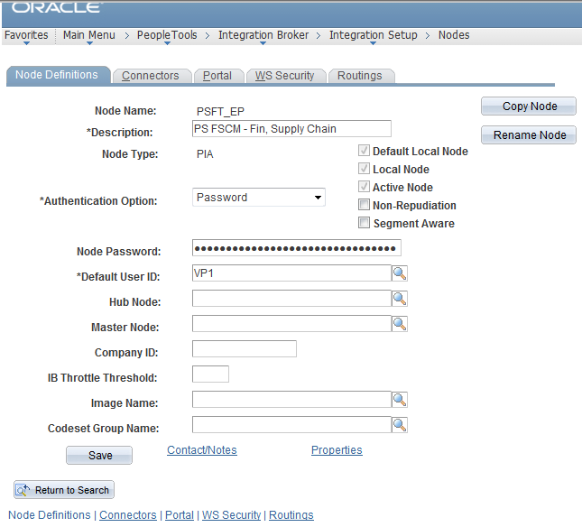
Created a node DELL | 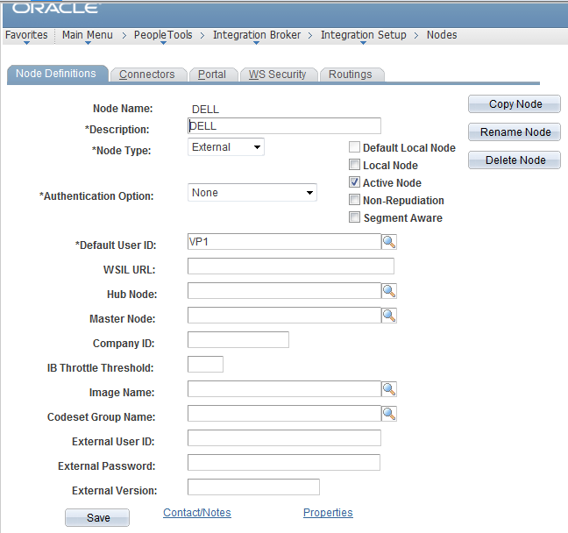
Provide the primary URL  https://b2bpreview.dell.com/invoke/B2BDirect.Entry/processDocument | 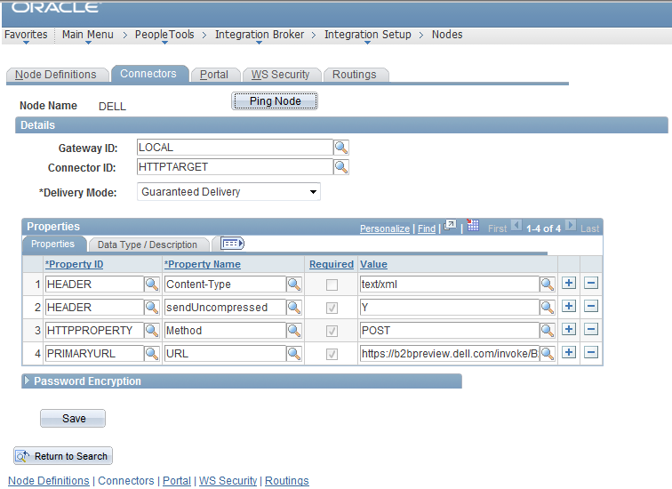
Created the routing PV_DC_CONNECT_REQS | 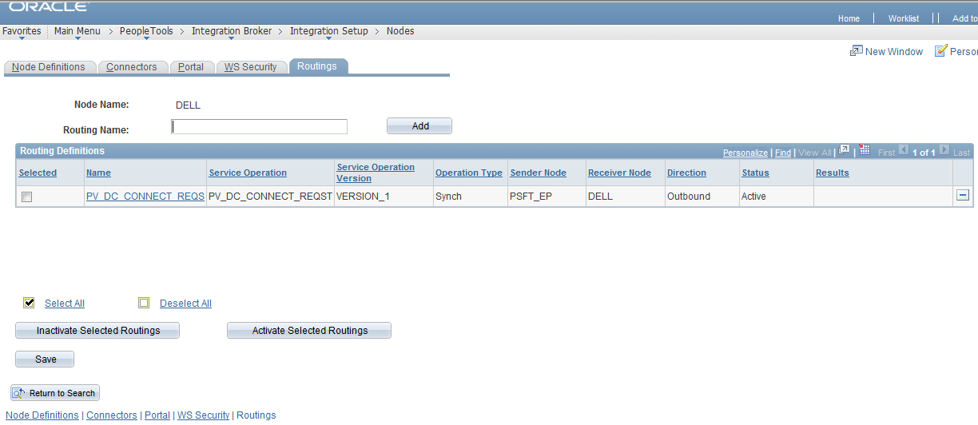
Provided the sender and receiving node | 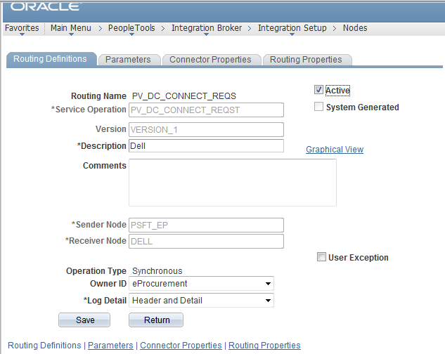
Provided the details like message version for inbound and outbound response. | 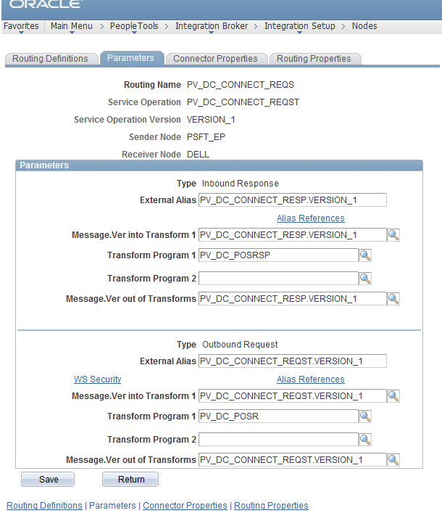
Created one more node DELL_PO | 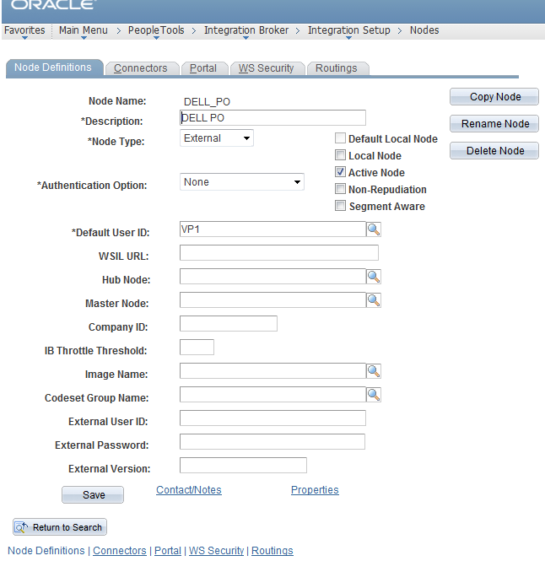
Provided Primary URL | 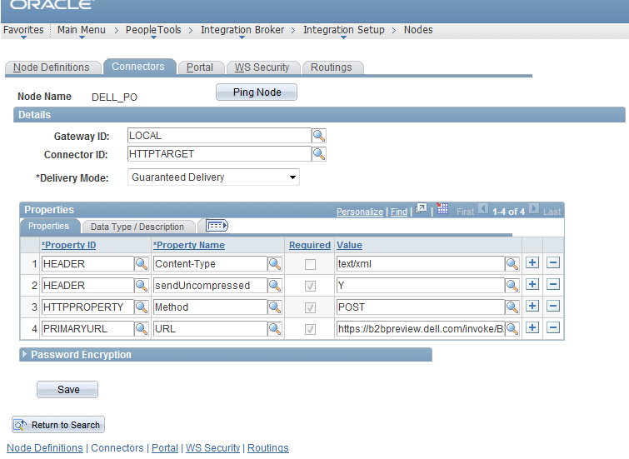
Created a Routing | 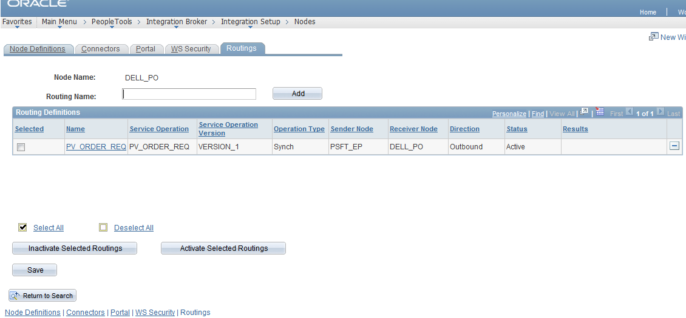
Added the sender node and receiver node. | 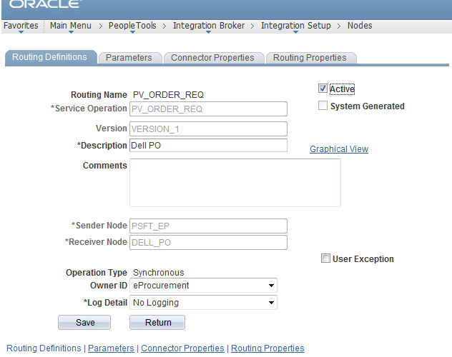
Provided the Inbound and Outbound response details | 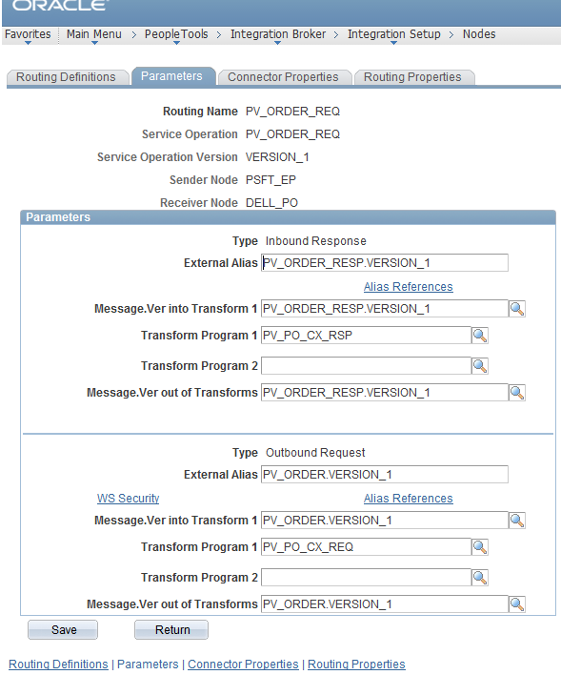
Set up the “Linked Supplier” from the “Administer Procurement” page by clicking the “Maintain Supplier Integration” link. | 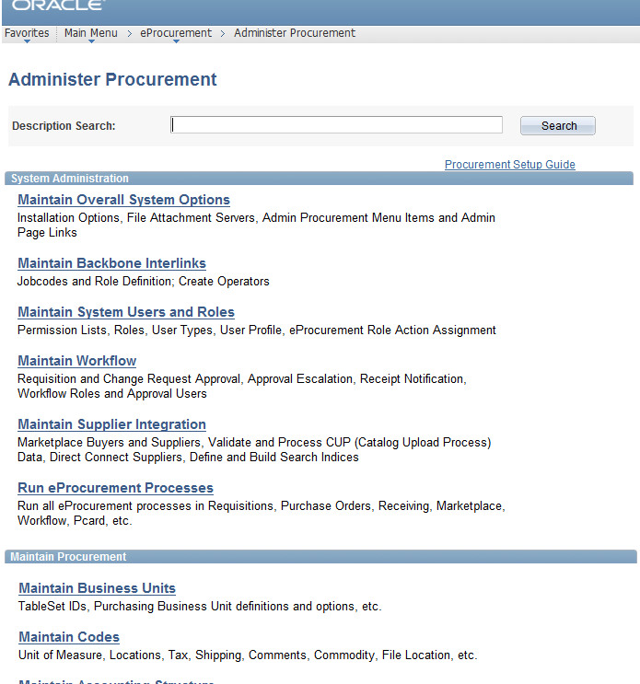
Maintain Supplier Integration | 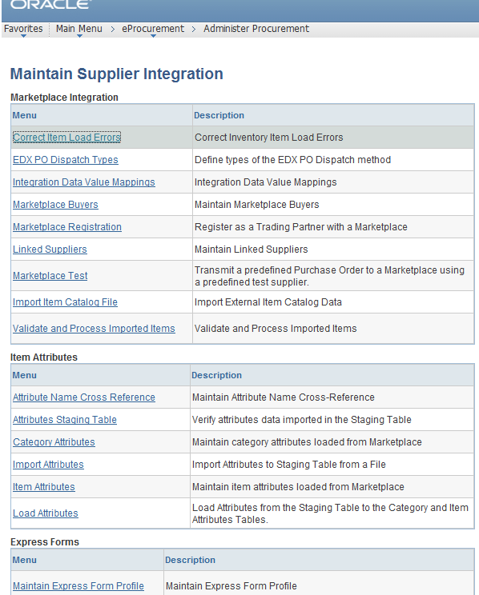
Linked Supplier Page | 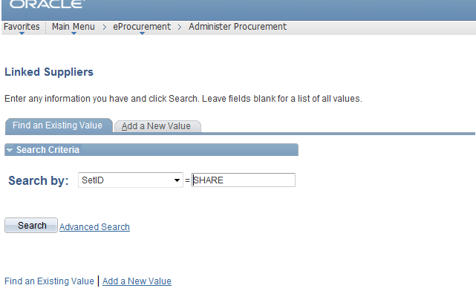
Provide the PO Dispatch and Direct Connect Node details | 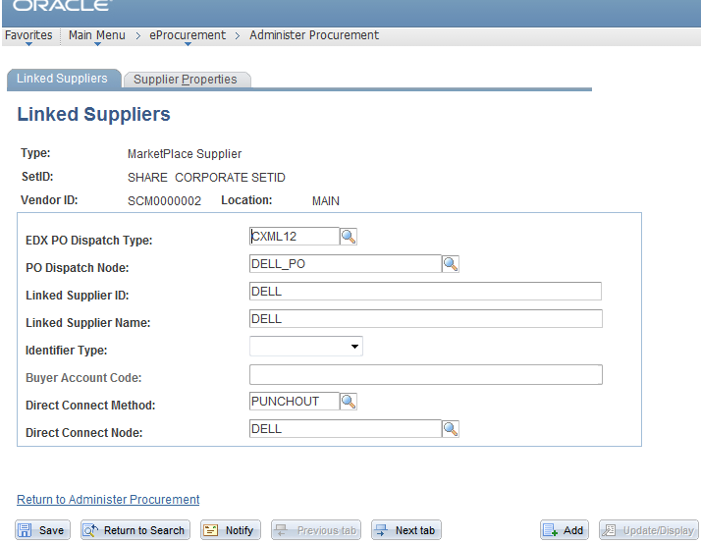
Provide the details as mentioned in this page. It did not work without domain and identity details. | 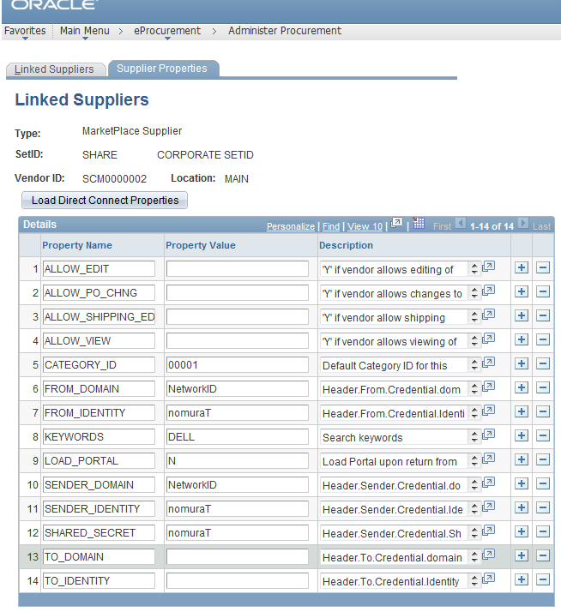
Create a requisition | 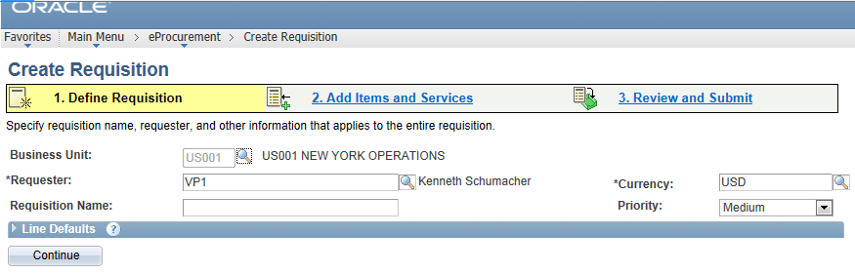
Go to Add Items and Services link and select web tab. | 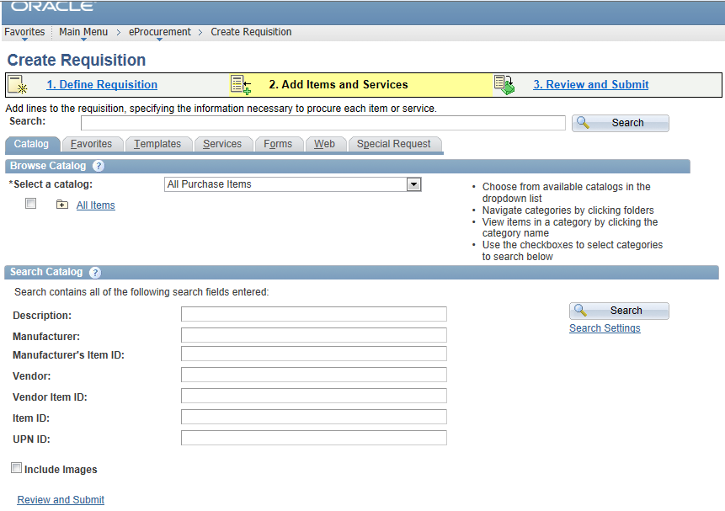
Click on the link for the vendor you set up. | 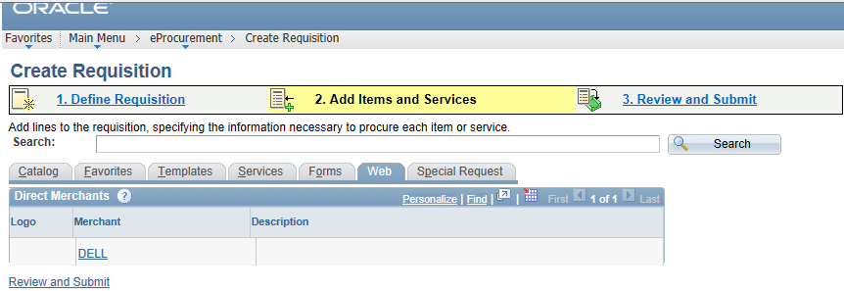
The dell website opens based on the agreement with the vendor. Select the item and click “Add to cart” | 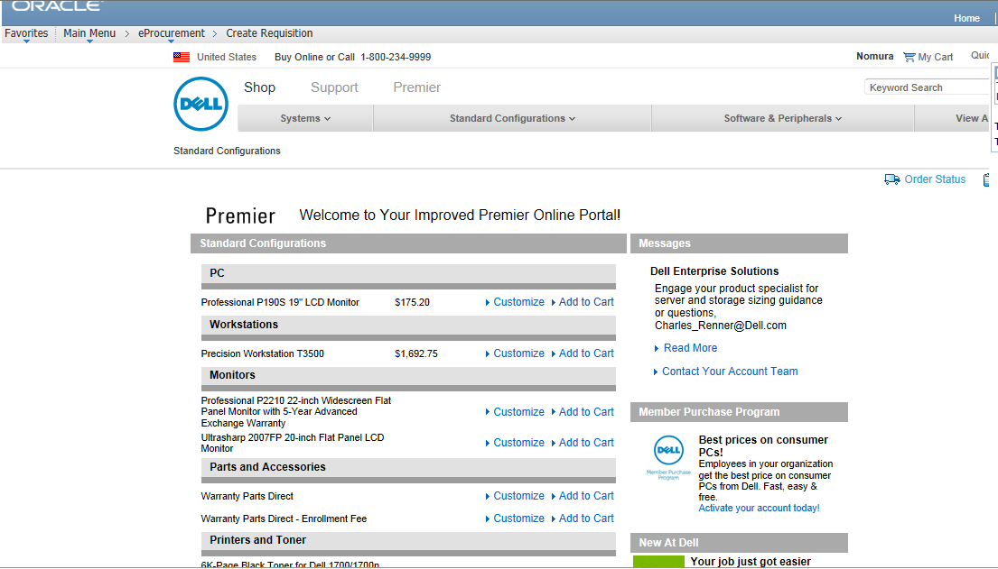
Choose quantity and provide other details | 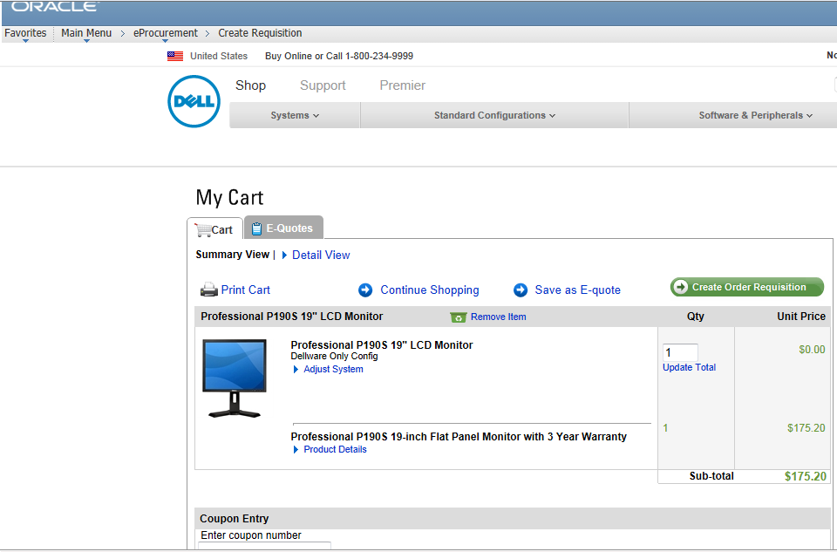
Other details | 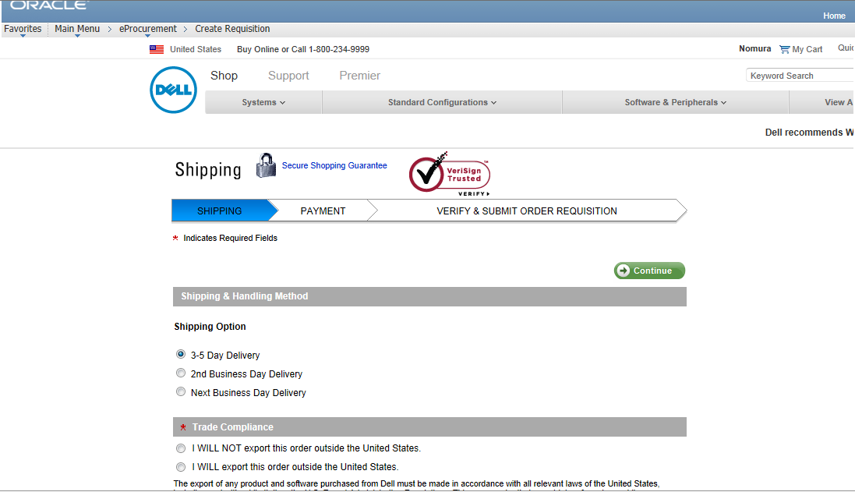
Additional Details | 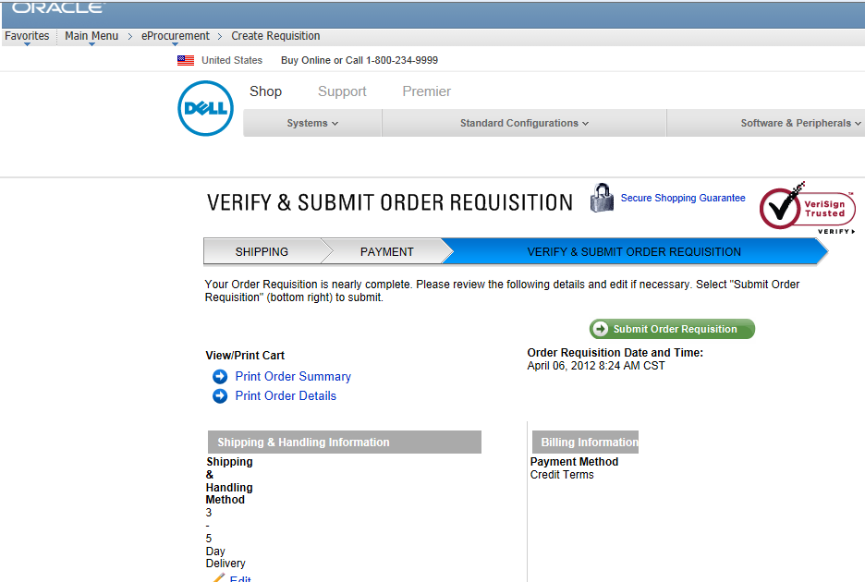
The requisition is brought back to the PeopleSoft page. | 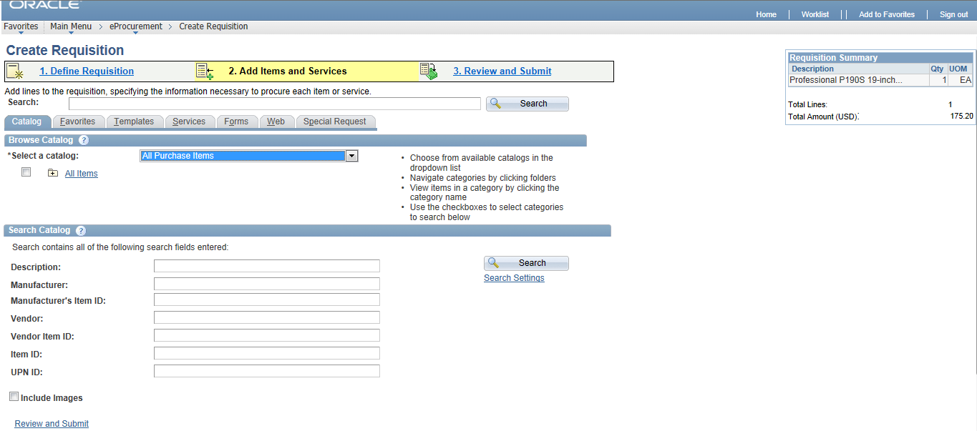
Click on Review and Submit page to submit the requisition for approval | 